Hazel Class Newsletter
Spring 2026

Dear Parents and Carers,
Welcome back after the Christmas break and Happy New Year! We hope you enjoyed spending time with your families during the holidays.
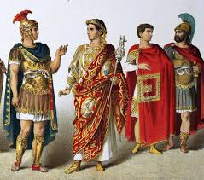
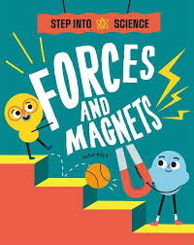
Our term has started with Science Week, and we have been exploring forces and magnets. We have been investigating the properties of magnets and forces, through activities, experiments and games. We have finished the week off creating our own magnetic games to sell to a local toy company and the children have loved it.

We have some interesting topics planned for this term, starting with learning more about how the Romans changed Britain and their significance in history. We have a very exciting trip booked to Fishbourne Roman Palace in February, to see some Roman artefacts. and we cannot wait! We will discover what happened at Pompeii and use our knowledge of volcanoes to write creatively about stories linked to our history work.

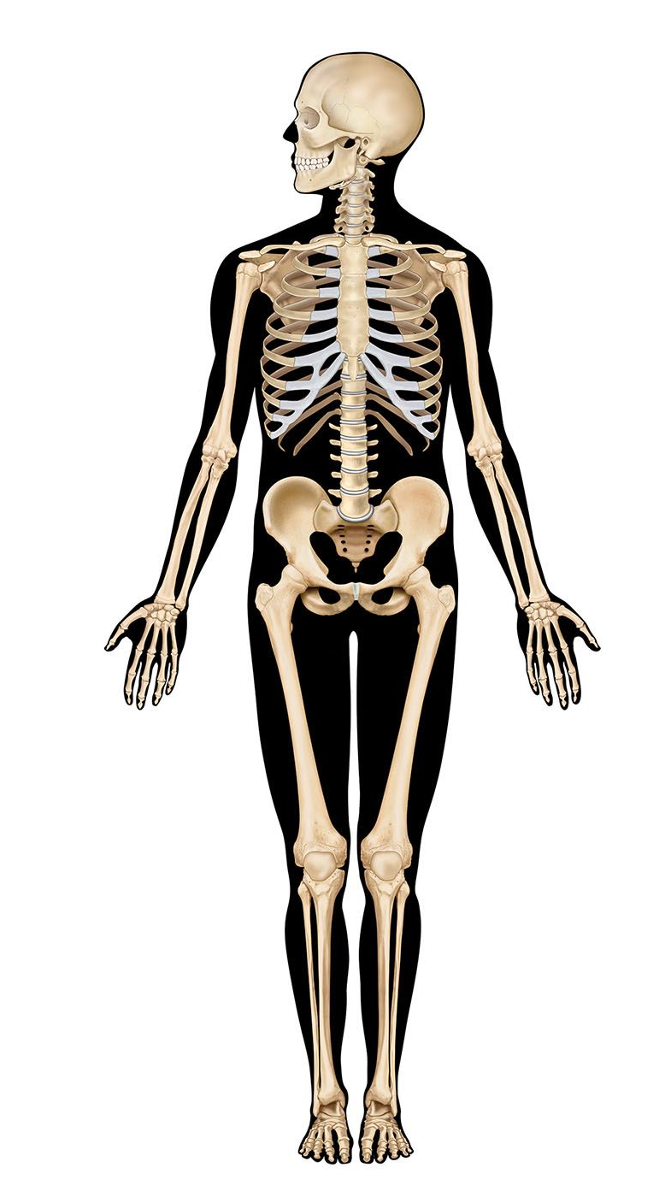
After the half term break, we will be learning about Humans and Animals – Bones and Skeletons. We will start by learning names for parts of the body and move on to finding out some of the scientific names for the bones. We will compare human and animal skeletons and how bones and muscles work to support us. Our science work will also look at keeping healthy. Linked to this work will be our Design and Technology work on healthy eating and types of food.

English
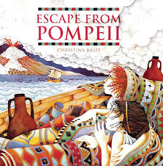
Our English book focus this term will be ‘Escape from Pompeii’ . With a focus of Roman times and volcanoes. We will continue to improve our knowledge of grammar, punctuation and vocabulary through our writing about Science, History and also within our reading. The class has really enjoyed reading longer books and texts this year and we will continue to build this love of reading with new titles this term as well as looking at some Roman myths.
Reading remains an important area and we welcome your support in reading daily at home with your child. It is really helpful to us if you record when you hear your child read in their reading journal. Please encourage them to ask and answer questions as they read their books as this will help them when they take the quiz for their book at aschool.
We will be concentrating on learning spelling patterns, which children should then use in their writing. Homework will be set to develop children’s recognition and spelling of commonly used words ( Year 3/4 common exception words). There are some fun games online which can help with spelling and I often put the links for these alongside homework.
Maths
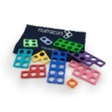

Please continue to support your child’s maths by learning times tables and number facts. You have received a login to a site called Times Table Rockstars. Here your child can build their fluency and speed with tables in a fun way at home and we have weekly updates on how each class performs on this website. Some of our class are improving their skills really well and linking their knowledge to maths work in class as a result. Tables will be a focus of many of our maths topics this term and we will have regular checks on how children are progressing. Fluency and the ability to recall number facts quickly is vital in their maths learning. In Year 4 the children will complete the national times tables assessment, so learning them now will leave plenty of time to rehearse and consoildate knowledege for this.
Homework
Reading, spellings, times tables and learning number facts will continue to be very important aspects of the support you can give your child in their learning.
Work on TT Rockstars is expected daily for all children and work on Numbots will also strengthen their number knowledge and skills.
Mymaths work should help children to consolidate and extend their classwork and may be completed over a number of weeks. This work will reinforce what we have done in class.
I will continue to set topic homework on Seesaw. These activities will support class work and children should aim to complete these tasks within a week or by the given date.
PE this year
Our PE sessions are timetabled for Tuesdays and Thursdays this term and we will be focussing on Rugby and Dance. Children should continue to come to school dressed in PE kits so that they are ready, and don’t forget warmer clothes, trainers and a change of socks for outdoor sessions. Please remove earrings and tie up long hair on these days. As our uniform policy states, Fit Bits and large watches are NOT allowed in school .
Looking Forward
If you wish to discuss anything regarding your child or you have any worries, then please make an appointment to see us through the Office or to have a phone conversation.
We are really looking forward to another exciting and interesting term with Hazel Class.
Mrs Calton, Mrs Knights, Mrs Hollamby and Mrs Williamson

