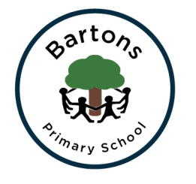
Year 2 Newsletter
Spring 2023

Welcome back to another exciting term at Bartons; hopefully you all had a wonderful Christmas break. The children have quickly settled back into our routines and are ready and raring to go with their new learning. PE will now take place on Mondays and Wednesdays.

Topic
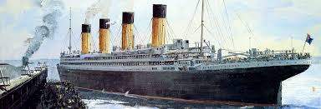
This term our topic is split into two parts. First half term our topic is ‘The Unsinkable’ where we will learn about the history of the Titanic and its tragic journey. All our wider curriculum and English work will be linked to it. We will be reading ‘Samson’s Titanic Journey’ in English to fully immerse ourselves into our topic.
After February half term we will be moving on to our ‘Frozen Kingdom’ topic where we will be learning about the North and South Pole. This will link to our work in Science about living things and their habitats. In Geography, we will be looking at weather patterns and making comparisons for two different locations.

English
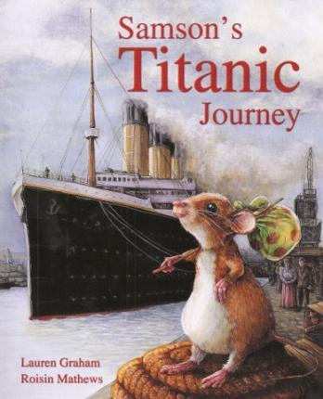
Our English work this half term is story writing, focusing on developing the middle of our stories. We will also be looking at writing a newspaper report on the Titanic as if we lived in 1912.
Alongside our writing we will be continuing to work on our grammar, spelling and phonics in order to prepare for the end of Year 2 SATS. We will also continue our hard work on handwriting which will be supported by daily activities.
Daily reading will also be vital for the children to reach the expected standards at the end of the year. It is therefore crucial that all children have their reading books in their book bags every day. This will be supported by whole class guided reading sessions where we will be focusing on the different reading skills the children need to develop.

Maths
We are continuing to use the Numicon approach where we link the concrete, pictorial and abstract to ensure children understand the concepts we are learning. We are moving onto multiplication and division and will be completing more reasoning activities to apply our knowledge. We will continue to look at SATS styled questions.

Homework
Take Away Tasks will continue to be set every Friday and will be due in the following Thursday. It is also expected that children are reading daily and are completing 60 minutes of TTRockstars (or Numbots) weekly.

How can you help?
- Regular reading at home where you can share stories, asking and answering questions about what you have read.
- Ensure they have their school reading book in school every day as the children will be expected to read it and those who are on Accelerated Reader can complete their quizzes.
- Encourage them to complete their homework tasks while letting them develop their independence.
- The children need to be at school promptly by the new time of 8:40.

Since Mrs Cook has left Chestnut Class we have been lucky to have Miss Jefferies and Ms Gregory join us – please see below for everyone’s working days:
Monday – Mrs Calton, Mrs Goodfellow & Miss Jefferies
Tuesday – Mrs Calton, Mrs Goodfellow & Miss Jefferies
Wednesday – Mrs Knights, Mrs Goodfellow & Ms Gregory
Thursday – Mrs Knights, Mrs Goodfellow & Ms Gregory
Friday - Mrs Knights, Mrs Goodfellow & Ms Gregory

Any problems or questions please do not hesitate to come and see us.
Mrs Calton, Mrs Knights
Mrs Goodfellow, Miss Jefferies & Ms Gregory

