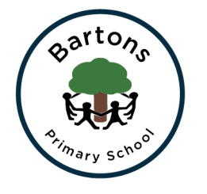
Year 2
Summer Newsletter

Welcome back after the Easter holidays. I trust that you all had a lovely break and were able to catch up with family and friends. We are looking forward to another fun-filled term with the children.

Topic
This term our topics are split in to two parts. This half term our topic is ‘Towers and Turrets’ where we will be learning about all things castle related – parts of a castle, jobs in a castle, knights and soldiers and we will even be looking at castles in our own locality.
After half term, our topic will be “Beachcombers” where we will be looking at the fishing history of Bognor Regis. We will also be learning about Mary Wheatland, a local hero and her bathing machines.

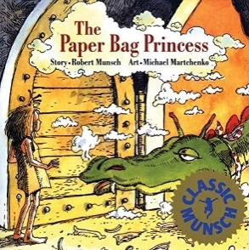
English
Linked to our “Towers and Turrets” topic, we will be looking at the book “The Paperbag Princess” as inspiration for our own writing. We will be continuing with our narrative writing and innovating a familiar story. Alongside this, we will also continue to work on our spelling, grammar and punctuation in our lessons. After half term our class text will be “The Secret of Black Rock” where we will be learning to write a persuasive letter.

Daily reading is vital for the children to reach the expected standards at the end of the year. This will be supported by regular whole class reading sessions where we will be focusing on the different reading skills the children need to develop alongside reading their reading book daily. Please ensure your child’s AR / Read Write Inc reading book and their monkey book is in their book bag every day.

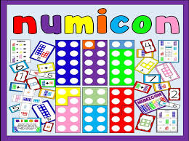
Maths
We are continuing to follow the Numicon approach which the children are now experts in! We are focusing on building our fluency within our Maths lessons and having a secure knowledge of adding and subtracting. On top of this, we will be revising everything we have learnt in Year 2 so far – particularly adding and subtracting two two-digit numbers, multiplying and dividing by 2, 5 and 10 and knowing fractions of quantities.

Homework
Take Away Tasks will continue to be set every Friday and will be due in Wednesday. The children will be expected to upload pictures / videos of their completed tasks onto SeeSaw. The children will receive spellings which will be tested on Wednesdays and a Maths task linked to our learning from that week.

PE
PE will be every Monday and Thursday. Please ensure your child comes into school wearing their full PE kit on these days. If your child has their ears pierced we ask that the earrings are removed before coming to school on these days.

How can you help?
- Regular reading at home where you can share stories, asking and answering questions about what you have read.
- Ensure they have their school reading book in school every day as the children will be expected to read it after lunch, a time where those who are on Accelerated Reader can complete their quizzes.
- Encourage them to complete their homework tasks while letting them develop their independence.
- Check our class page on the website to discuss their learning further.

Any problems or questions please do not hesitate to come and see us.
Miss Grimsey and Mrs Cook
Year 2 Team

