 | Autumn 1 | Autumn 2 | Spring 1 | Spring 2 |  | Summer 1 | Summer 2
Topic | ‘Somewhere to Settle’  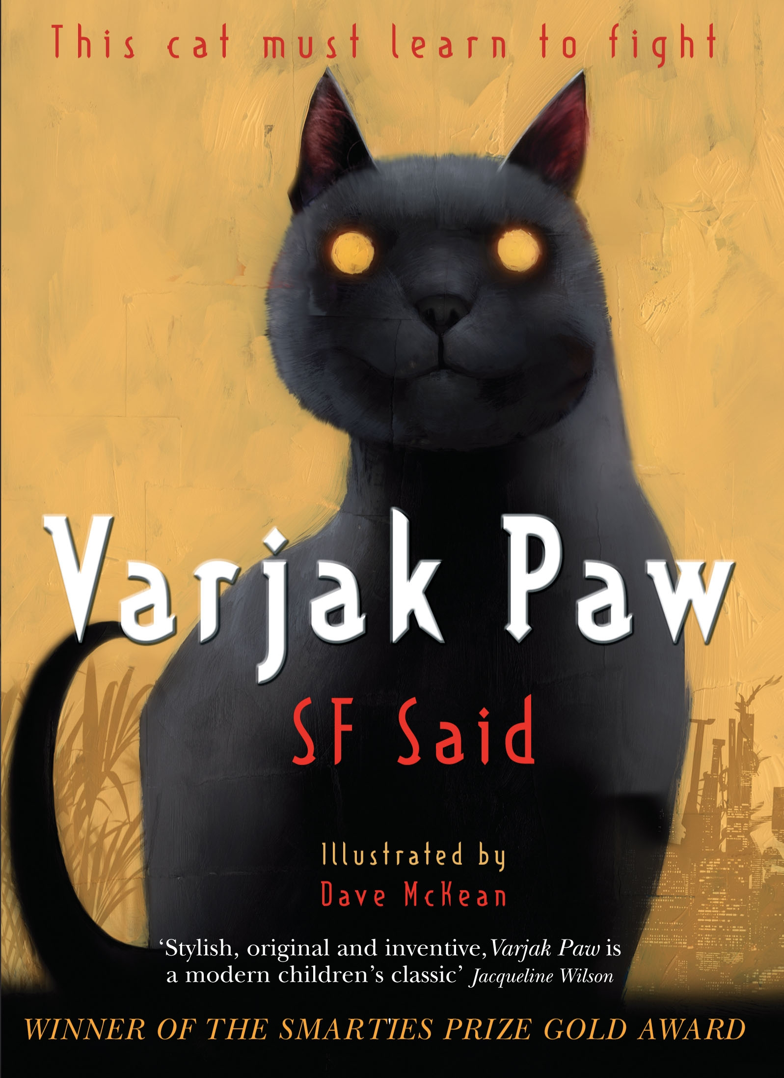 | Out of Africa  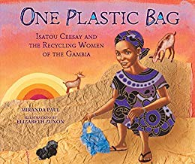  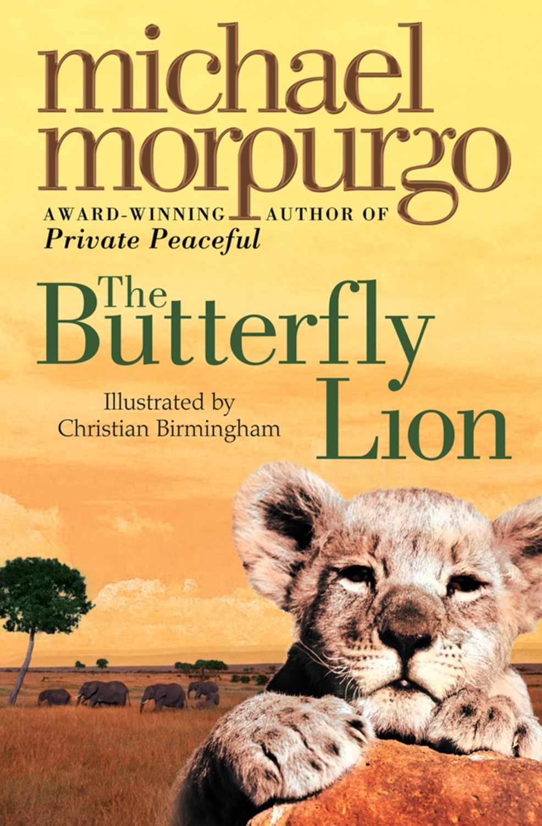 | ‘Seeking Refuge’  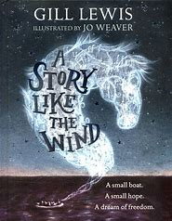 | ‘Off with her head!’  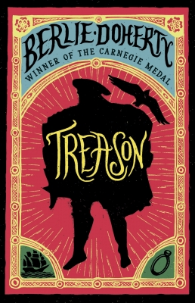 |  | Myths and Legends  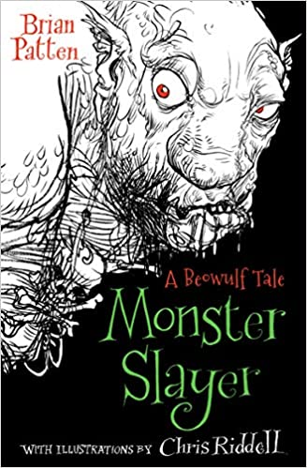 | Go with the flow  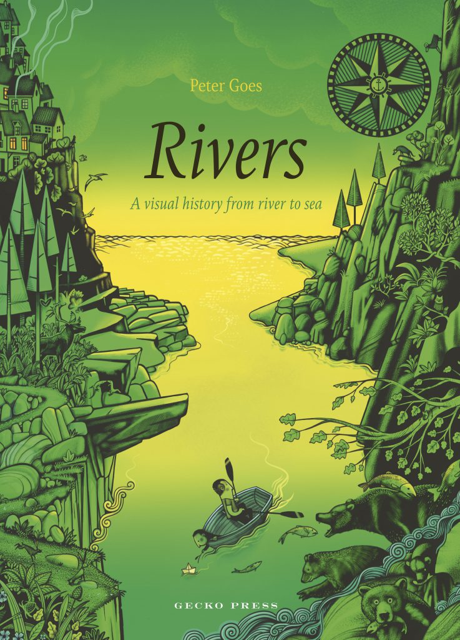
English | Setting for a Fear and Suspense story  Book - Varjax Paw | Rags to Riches  Book - One plastic Bag  Book – Butterfly Lion | Character flaw  Book – A story like the wind | Recount/Narrative  BOOK = Treason – Berlie Doherty  Shakespeare (2 weeks) |  | Non – Fiction writing  Beowulf (Guided Reading) | Quest/Journey  BOOK= Rivers
Science | Electricity | States of matter | Science week  Digestive system  Teeth | Sound |  |  | Food chains  Living things and their habitats
Computing | Scratch – creating algorithms  Online safety – social media | Scratch – creating algorithms  Digital images | Search Engines | Video uploads  green screen |  | Scratch – creating  Algorithms  Networks | Video uploads  green screen
History/ Geography | Human Geography, land use and settlements | Africa – climate zones/human geography  Locating world countries |  |  | Monarchs, Tudors, Tudor Life, Henry VIII, Shakespeare | Saxons  Germany linked to Saxons | Rivers  compass points, symbols on OS map
Art/ Design Technology | Creating sculpture with reused materials - e.g. cardboard  Enhanced by papermachie/Modroc | Block printing  African art  Oil pastel and acrylic paint fruit market by Dion Lewis | Food tech – heathy balanced meal. | Portraits  Jinx frame – Tudor house |  | Make a pop-up book about a myth / legend  Create/ paint mythical creature | Dynamic Sketching with Peter Hann  Bridges – Monet painting inspiration  Bridge making
PE | Hockey  Gymnastics | Striking and fielding  Outdoor and Adventurous activity | Dance  Ball skills | Striking and fielding  Dance |  | Athletics  Tennis | Cricket  Rounder’s
PSHCE | Feelings and emotions | Safety rules and laws | Physical activity and nutrition | Friendships and bullying. |  | Drugs education | Body changes
Core Values | Independence | Respect | Communication | Happiness |  | Responsibility | Creativity
RE | Christianity | The bible | Food and fasting | People of faith  Easter |  | Buddhism | pilgrimages
Music | Machine Music | Weather Music | Band Project | Band Project |  | Tudor Music | Water Music

