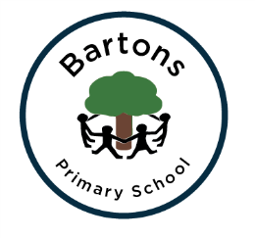 | WEST SUSSEX COUNTY COUNCIL  BARTONS PRIMARY SCHOOL Headteacher: Mrs Kate Powell  Lethaby Road, Bognor Regis,  West Sussex PO21 5EJ  Tel no. (01243) 822056 Fax no. (01243) 841580  email: office@bartonsprimary.school
27th February 2018
Dear Parent/Carer,
RE: Adverse Weather Procedures

Today, we have seen the first dusting of snow and so it is important to remind you about the procedures for adverse weather should we encounter significant snowfall. The forecasts this week, particularly for the end of the week, are quite mixed so we should be prepared just in case. As always, we will make the best decision based on the safety and well-being of all of our children, parents and staff at the school.

In the event of a school closure, the following things will happen. The school text service is our immediate alert system which will keep you up to date with emergency school information. We will also post messages on the homepage of the school website so please check that as often as you can. Please remember that no news is good news so if you haven’t heard anything then everything is running as normal. During ‘out of school hours’ and the school has to close, local radio stations and West Sussex County Council website will announce the closure. The radio stations to listen to will be BBC Sussex and Spirit FM.

In the event of heavy snow fall during the school day and if we had to close early, we will contact parents to ask you to come and collect your child/ren immediately. No child would be left at school but in the interests of everyone’s safety, we would hope that if you are unable to pick your own child up yourself, that you could make alternative arrangements with friends or family. Such occasions are very rare but we do need to be prepared.

I do hope that we won’t have to consider any closures but I would like to reassure you that any decisions made are done with the best intentions and in the interests of everyone’s safety.
Yours sincerely,

Mrs Kate Powell
Headteacher

