
Bartons Primary School Pupil Premium Strategy Statement 2021-2024

This statement details our school’s use of pupil premium (and recovery premium for the 2021 to 2022 academic year) funding to help improve the attainment of our disadvantaged pupils.

It outlines our pupil premium strategy, how we intend to spend the funding in this academic year and the effect that last year’s spending of pupil premium had within our school.

School overview
Detail | Data
School name | Bartons Primary School
Number of pupils in school | 206
Proportion (%) of pupil premium eligible pupils | 17%
Academic year/years that our current pupil premium strategy plan covers (3 year plans are recommended) | Sept 2021 to  Dec 2024
Date this statement was published | December 2021
Date on which it will be reviewed | Reviewed December 2024 December 2024
Statement authorised by | Kate Powell Headteacher
Pupil premium lead | Ali Powell  Deputy Headteacher
Governor / Trustee lead | Mr C Barratt  Chair of Governing Board
Funding overview
Detail | Amount
Pupil premium funding allocation this academic year | £55,561
Recovery premium funding allocation this academic year | £13,521
Pupil premium funding carried forward from previous years (enter £0 if not applicable) | £56,992
Total budget for this academic year  If your school is an academy in a trust that pools this funding, state the amount available to your school this academic year | £126,073

Part A: Pupil premium strategy plan

Statement of intent
At Bartons Primary School our intention to ensure that all pupils can achieve their full potential in all areas of school life, irrespective of their background or the challenges they face. We strive to provide opportunities for all children to succeed and benefit from an enriching curriculum and school experiences, whilst also embedding the values of Team Bartons: Independence, Respect, Communication, Happiness, Responsibility and Creativity.
The staff at Bartons Primary School share the collective goal to keep all children safe and to support them academically and emotionally. We adopt a whole school inclusive approach in which all staff take responsibility for disadvantaged pupils’ outcomes and raise expectations of what they can achieve. In order to narrow the attainment gaps between disadvantaged pupils and their non-disadvantaged counterparts both within school and nationally, we are committed to early identification, recognition and the removal of potential barriers to learning. All staff apply the principles of Ordinarily Available Inclusive Practice (OAIP) from West Sussex County Council.
The approaches identified in this strategy are based on the common challenges faced by disadvantaged pupils, our knowledge of individual pupil needs identified through teacher assessments and observations, as well as information gained from robust diagnostic assessments. High-quality teaching is at the heart of our approach. This is proven to have the greatest impact on closing the disadvantage attainment gap and at the same time will benefit the non-disadvantaged pupils in our school. Additional targeted interventions and 1:1 or small group School-led tutoring also form part of the strategy to ensure the recovery for those pupils whose education has been worst affected by the pandemic. Alongside academic support, we will ensure that pupils who have social, emotional and mental health needs will access high quality provision from appropriately trained adults.

Challenges

This details the key challenges to achievement that we have identified among our disadvantaged pupils.
Challenge number | Detail of challenge
1 | Pupils’ language and communication skills are underdeveloped when starting school. This needs to be prioritised in the EYFS and throughout KS1 with targeted intervention for those who are identified at risk.
2 | Pupils’ vocabulary is limited on entry to school and across all age groups – most commonly in SEND and pupils eligible for pupil premium. This does not develop quickly due to the lack of exposure to the wider world and needs to be explicitly taught as part of the curriculum.
3 | Disadvantaged pupils generally have greater difficulties with phonics than their peers. This negatively impacts their development as readers. Attainment in reading, particularly at the GDS standard is inconsistent across the rest of the school. The maintenance of the robust phonics programme and work on whole class guided reading must continue to be prioritised.
4 | Low levels of writing attainment within disadvantaged cohorts and the gap between them and their peers was further impacted by school closure. Overall, pupils achieve well by the end of KS2 but fail to convert to greater depth standard due to gaps in their knowledge. Daily high impact initial teaching of writing is essential.
5 | Low levels of Maths attainment within pupil premium cohorts and the gap between them and their peers was further impacted by school closure. Attainment in maths is inconsistent across the school. Daily high impact initial teaching and work on mastery, fluency and number sense are crucial.
6 | Our attendance data for the 2020-2021 indicates that absence among disadvantaged pupils was 4.34% this is higher than for non-disadvantaged pupils at 2.67% (Last reported national figure published in 2018-2019 4.7%)  14.9% of disadvantaged pupils have been ‘persistently absent’ compared to 3.1% of their peers during that period. (Last reported national figure published in 2018-2019 was 10.9%)  Our assessments and observations indicate that absenteeism is negatively impacting disadvantaged pupils’ progress. Analysis of reasons for absence observations and discussions with pupils and families have identified social and emotional issues for pupils. Our attendance data for the 2021-2022 indicates that absence among disadvantaged pupils was

Intended outcomes
This explains the outcomes we are aiming for by the end of our current strategy plan, and how we will measure whether they have been achieved.
Intended outcome | Success criteria
To increase disadvantaged pupils’ levels of engagement and attitudes towards reading by ensuring that early reading and phonics are prioritised. | - All staff across the school are trained in the effective and consistent approach to the teaching of phonics through effective ongoing CPD and collaboration with RW Inc.  - At least 90% of pupils will achieve the National expected standard in the PSC in 2022 and this will increase to 95% in 2024. Disadvantaged children will attain PSC in line with non-disadvantaged.  - The bottom 20% for phonics are tracked and supported to maximise their reading abilities. Same day interventions are provided through mastery, pinny time and 1:1 phonics tutoring.  - The use of reading interventions for the bottom 20%, including the use of comprehensions groups, RWInc Fresh Start and 1:1 tutoring are tracked and refocussed as needed.  - KS1 reading outcomes in 2024/25 show that disadvantaged pupils will attain ARE in reading in line with non-disadvantaged pupils.  - KS2 reading outcomes in 2024/25 show that disadvantaged pupils will attain ARE in reading in line with non-disadvantaged pupils.
To ensure that all children’s early language and communication development is prioritised in the EYFS and KS1 with targeted intervention. | - Key staff and TA’s are trained on NELI, to develop early language and communication development strategies/approaches. Progress seen from baseline.  - Assessments and observations indicate significantly improved oral language among disadvantaged pupils across the school.  - Speech and Language targeted programmes are in place and reviewed half termly. There will be a reduction in the number of disadvantaged pupils/bottom 20% who need additional speech and language intervention.
To ensure that the curriculum enables disadvantaged children to develop their vocabulary and provide them with opportunities to use and practise new language. | - Vocabulary Ninja is embedded in daily practise and the taught vocabulary can be seen in written work and heard in spoken activities.  - Pupil enthusiasm and interest in new words is high.  - Progress in morphology, phonology, etymology and orthography revealed by HAST II screening.  - Improvements seen in attainment and progress data for reading and writing at all stages. The attainment gap between disadvantaged and non-disadvantaged pupils is reduced.  - Subject leaders ensure progressive key vocabulary from core and foundations subjects are taught in lessons.
To ensure consistent high impact inclusive initial teaching for disadvantaged pupils. | - All staff refer to the OAIP document as part of their classroom practise and through discussion can show how this has been applied to support groups of pupils.  - Positive feedback is received regarding training on dialogic talk, questioning strategies and other CPD provided by senior leaders.  - Evidence of the impact of whole staff and individual CPD seen in monitoring activities.  - Effective high quality feedback is given and leads to improved outcomes for all pupils.
Improved reading, writing and Maths attainment among disadvantaged pupils at the end of KS1 and KS2 | - KS1 and 2 writing outcomes in 2024/25 show that disadvantaged pupils will attain ARE in reading in line with non-disadvantaged pupils.  - KS1 and 2 maths outcomes in 2024/25 show that disadvantaged pupils will attain ARE in reading in line with non-disadvantaged pupils.
To achieve and sustain improved wellbeing for all pupils, particularly the disadvantaged pupils. | By 2024:  - A clear whole school approach for mental health and wellbeing is in place and embedded.  - The RSHE scheme of work is embedded, reviewed and adapted to meet the needs of the current cohorts.  - Pupil voice, pupil and parent surveys and teacher observations reveal sustained positive mental wellbeing.  - Participation by all pupils in enrichment activities is sustained.  - Impact of the learning mentor sessions shows improvements in social and emotional needs form baseline on Socially Speaking questionnaire or Boxall profile.
To sustain high attendance for all pupils, particularly the disadvantaged pupils. | By 2024:  - Pupil absence is no higher than 4.7%  - There is no attendance gap between disadvantaged pupils and their non-disadvantaged peers.  - The percentage of all pupils who are persistently absent is below 10.9%  - There is no gap between the persistent absence figures for disadvantaged and non-disadvantaged pupils.  - In house data shows disadvantaged pupils perform broadly in line with non-disadvantaged pupils.

Activity in this academic year
This details how we intend to spend our pupil premium (and recovery premium funding) this academic year to address the challenges listed above.

Teaching
Budgeted cost: £59,000
Activity | Evidence that supports this approach | Challenge number(s) addressed
Purchase further standardised diagnostic assessments and analysis tools.  NFER and hub access for analysis  OUP NC tests and Merit analysis tool.  Embed the process of ensuring ongoing diagnostic assessments take place in learning journeys. | Standardised tests have provided reliable insights into the specific strengths and gaps in knowledge for each pupil (and trends across cohorts) this is used to help ensure pupils receive the correct additional support through interventions or teacher instruction.  EEF Assessment and Monitoring Progress  Evidence shows that when used effectively, diagnostic assessments (Quizzes, exit tickets, hinge questions, mind-maps) can indicate areas for development with individual pupils or across classes and year groups. Some methods can also help teachers isolate the specific misconceptions pupils might hold.  EEF Diagnostic Assessment | 1,2,3,4,5
Provide ongoing quality in-house CPD opportunities to ensure high impact initial teaching  - Questioning  - Feedback  - Dialogic talk  - Metacognitive strategies | Feedback demonstrates this has significant benefits for pupils, particularly disadvantaged pupils. The development of high quality questions and questioning strategies also improves engagement.  EEF Feedback and Questions  There is a strong evidence base that suggests oral language interventions, including dialogic activities such as high-quality classroom discussion, are inexpensive to implement with high impact.  EEF Dialogic Teaching  Metacognition and self-regulation approaches to teaching support pupils to think about their own learning more explicitly, often by teaching the pupils specific strategies for planning, monitoring, and evaluating their learning.  EEF Metacognition and Self-Regulated Learning | 1,2,3,4,5
Provide ongoing high quality in-house CPD opportunities to support staff identification of barriers and provision (OAIP) | An inclusive and holistic approach which enables pupils to be a part of the ethos of the school enables them to access the curriculum and achieve the best outcomes.  Ordinarily Available Inclusive Practice WSCC | 3,4,5,6
Continue ongoing monitoring of robust systematic synthetic phonics – RW Inc.  Ensure CPD for all staff is provided where needed.  Participate in further development day with RW Inc trainer to ensure delivery is the best it can be.  Monitor whole class guided reading reading provision across KS1 and KS2 and provide timely feedback to improve teaching and learning. | Phonics approaches have a strong evidence base that indicates a positive impact on the accuracy of word reading (though not necessarily comprehension), particularly for disadvantaged pupils:  Phonics Research EEF  Ruth Miskin Read Write Inc Impact Research  The average impact of reading comprehension strategies is an additional six months’ progress over the course of a year. Successful reading comprehension approaches allow activities to be carefully tailored to pupils’ reading capabilities, and involve activities and texts that provide an effective, but not overwhelming, challenge.  DFE Reading Framework  EEF Reading Comprehension Strategies | 2,3
Develop the use of Vocabulary Ninja across the whole school to support the breadth of vocabulary used in spoken language and written tasks. | Evidence shows that having a good vocabulary underpins progress, impacts on attainment, affects self-esteem and behaviour and plays a huge role in a child’s future life chances. Without enough language – a word gap – a child is seriously limited in their enjoyment of school and success beyond.  OUP: Why Closing the Word Gap Matters  OUP: How Schools are Closing the Word Gap  Numicon The Importance of Mathematical Language  EEF Oral Language Interventions | 1,2,3,4,5,6
Further enhance maths teaching and curriculum planning in line with DfE and EEF guidance – fluency and mastery.  Continue to access Numicon Advocacy school support and CPD (including Teaching for Mastery training).  Maths specialist teacher role in school – non-class based to provide ongoing CPD  Continue subscription to Number sense and pay for staff to complete In depth training. | Evidence shows that excellent maths teaching requires good content knowledge. Excellent teachers also know the ways in which pupils learn mathematics and the difficulties they are likely to encounter, and how mathematics can be most effectively taught.  DFE Maths at KS1 and 2  EEF Maths at KS2 | 5
Improve the quality of social and emotional learning.  Social and emotional approaches will be embedded into routine educational practices and supported by professional development and training for staff.  Continue to use the Learning Mentor sessions and provide play therapy where needed. | There is extensive evidence associating childhood social and emotional skills with improved outcomes at school and in later life (e.g., improved academic performance, attitudes, behaviour and relationships with peers):  EEF Social and Emotional Learning | 6
Targeted academic support
Budgeted cost: £ 41,000
Activity | Evidence that supports this approach | Challenge number(s) addressed
Screen pupils and implement the Nuffield Early Language Intervention for children in EYFS. Ensure an additional staff member is trained in the delivery of this.  To continue early intervention led by speech and language therapist putting interventions in place early. | Oral language interventions can have a positive impact on pupils’ language skills. Approaches that focus on speaking, listening and a combination of the two, show positive impacts on attainment.  EEF Oral Language Interventions  Nuffield Early Language Intervention | 1,2
Additional phonics sessions targeted at disadvantaged pupils who require further phonics support. | Phonics approaches have a strong evidence base indicating a positive impact on pupils, particularly from disadvantaged backgrounds. Targeted phonics interventions have been shown to be more effective when delivered as regular sessions over a period up to 12 weeks  Phonics Research EEF  Ruth Miskin Read Write Inc Impact Research  EEF Freshstart Y5-6 | 3,
Maths specialist teacher role in school – non-class based. Use this time to reduce class size, team teach and deliver intervention via fluency work, Numicon intervention and pre-teaching. Disadvantaged pupils involved in many of these groups. | Evidence shows that if the reduction is large enough to permit the teacher to change their teaching approach when working with a smaller class (less than 20) allows for a change in teaching approach then benefits on attainment can be identified, in addition to improvements on behaviour and attitudes.  EEF Reducing Class Size  Tuition targeted at specific needs and knowledge gaps can be an effective method to support low attaining pupils or those falling behind.  EEF Small Group Tuition  Numicon Big Ideas at Bartons | 5
School led tutoring programme in place for January 2022 to provide for pupils whose education has been most impacted by the pandemic. A significant proportion of the pupils who receive tutoring will be disadvantaged, including those who are high attainers | Small group tuition targeted at specific needs and knowledge gaps can be an effective method to support low attaining pupils or those falling behind.  EEF Small Group Tuition  EEF Freshstart Y5-6 | 3,4,5
Wider strategies
Budgeted cost: £2,000
Activity | Evidence that supports this approach | Challenge number(s) addressed
Whole staff training on:  - Trauma informed practice  - Attachment/ACE  - Executive functioning.  RSHE developed and emotional health and wellbeing a priority.  Embed whole school approach for mental health.  To develop quiet low stimulus environment to enable pupils to be prepared to learn and self-regulate. (Development of SEND sensory areas and outside gardens and space not through PPG funding) | Evidence that appropriately trained and supported staff, teachers and TAs can achieve results with mild to moderate mental health problems.  https://traumainformedschools.co.uk/  The training we have selected will focus on the staff CPD needs identified through the online tool: to develop our understanding of our pupils’ needs, give pupils a voice in how we address wellbeing, and support more effective collaboration with parents.  DfE SMHL training | 1,2,3,4,5,6
To ensure subsidized experiences enhance academic learning, create opportunities to develop aspiration and give children opportunities to excel in area they might not otherwise have access to. | Offering a wide range of high-quality extracurricular activities to boost wellbeing, behaviour, attendance, and aspiration. Activities will focus on building life skills such as confidence, resilience, and socialising. Disadvantaged pupils will be encouraged and supported to participate.  EEF Life Skills and Enrichment | 1,2,3,4,5,6
Embedding principles of good practice for attendance set out in the DfE’s advice. | The DfE guidance has been informed by engagement with schools that have significantly reduced levels of absence and persistent absence.  DFE Securing Good Attendance | 6

Total budgeted cost: £102,000

Part B: Review of outcomes in the previous academic year premium strategy outcomes December 2024.
This details the impact that our pupil premium activity had on pupils in the 2023 to 2024 academic year.
Challenge 1 - To improve pupils’ language and communication skills in EYFS and KS1.
Outcome
NELI interventions have been carried out by trained staff. There are 3 members of staff trained to deliver this intervention.
Alert Level according to NELI screening. | % of children at the start of the programme Sept 23 | % of children at the end of the programme July 24
High Concern | 17% | -
Slight Concern | 33% | -
No Concerns | 50% | 100%
The results show that the NELI programme has been successful for all pupils in improving their speech, language and communication. Of the pupils taking part in the intervention 40% were eligible for the pupil premium. NELI is already underway for the academic year 2024-2025.
SALT interventions have been delivered under the direction of the speech and language therapist including the use of colourful semantics to improve sentence formation. During the year, 17 children worked on individual SALT programmes of these 5 children were eligible for the pupil premium grant.
Challenge 2 - To improve pupils’ vocabulary
Outcome
Vocabulary Ninja has continued to impact children’s word knowledge. This is evident through observation and sampling of spoken and written language. Vocabulary Ninja primarily impacts the children’s knowledge of Tier 2 vocabulary. The updated curriculum for foundation subjects is now embedded and the teaching and use of tier 3 technical language is part of all lessons. Assessment of the foundation subjects includes the children’s use of technical language.
Challenge 3 - To ensure disadvantaged pupils develop the skills needed for early reading.
Outcomes
Reading July 2024 | Whole School | PPG
Attainment EXS+ | 69% | 50%
Attainment GDS | 18% | 10%
Expected progress + | 74% | 95%
Accelerated progress | 16% | 13%

In reading the pupils’ eligible for pupil premium attained lower than the figure for ‘all pupils’ but expected progress is above and accelerated progress are broadly in-line. 1:1 phonics and reading support is planned and delivered through PPG plans and in some cases the ILP planning overlap with this
Statutory Outcomes for Reading
Reading | All pupils | PPG
ELG | 77% | 50%
Phonics Y1 | 73% | 40%
Phonics Retakes | 50% | 50%
Attainment at Y2 (Not statutory) | 69% | 57%
Attainment at Y6 | 70% | 57%

Of the disadvantaged pupils in Early Years (4 pupils) 2 achieved ELG in reading. Early reading, along with communication and language, are always prioritised in the EY curriculum and the overall percentage of 77% represent good progress from the low baseline.
Year 1 phonic outcomes for disadvantaged pupils are lower than for all pupils. This will continue to be monitored through differentiated phonics groups, regular assessment and 1:1 tuition. The group will be supported in English sessions later in Year 2.
The Year 2 phonics retakes for pupil premium pupils shows that 50% of the pupils achieved the expected outcome. The other children are all supported through an ILP. They receive targeted and individualised support with phonics.
The outcomes for disadvantaged pupils remain lower than for all pupils at present. All necessary provision is identified in ILPs, PPG records and through the areas highlighted by the school development plan and subject leader plans.
Challenge 4 – To ensure disadvantaged pupils develop the skills needed for writing.
Outcome
Writing | Whole School | PPG
Attainment EXS+ | 62% | 50%
Attainment GDS | 4% | 0%
Expected progress + | 80% | 98%
Accelerated progress | 11% | 8%

In writing the pupils’ eligible for pupil premium attained lower than the figure for ‘all pupils’ as is expected progress. Writing remains a whole school priority on the School Development Plan and is reviewed in detail during pupil progress meetings.

Statutory Outcomes for Writing
Writing | All pupils | PPG
ELG | 67% | 50%
Attainment at Y2 (not statutory) | 62% | 43%
Attainment at Y6 | 70% | 71%
Of the disadvantaged pupils in Early Years (4 pupils) two achieved ELG in writing. Early writing, along with communication and language, are always prioritised in the EY curriculum and the overall percentage of 67% represents very good progress from the very low baseline.
The outcomes for disadvantaged pupils compare well in Year 6 to the ‘all’ pupils outcome due to the increased focus on writing stamina, vocabulary and sentence structure. These areas remain a focus on the English Leader’s strategy plan.
Challenge 5 – To ensure disadvantaged pupils develop the skills needed for maths
Outcomes
Maths | Whole School | PPG
Attainment EXS+ | 80% | 50%
Attainment GDS | 13% | 18%
Expected progress + | 79% | 95%
Accelerated progress | 13% | 18%
In maths, the pupils’ eligible for pupil premium attained lower than the figure for ‘all pupils’ but expected progress is above all pupils. The data from July 2024 reveals that girls are currently not attaining as well as previously and the maths leader strategy plan will address this.
Statutory Outcomes for Maths
Maths | All pupils | PPG
ELG | 80% | 50%
Attainment at Y2 (not statutory) | 72% | 71%
Full marks in MTC | 73% | 71%
Attainment at Y6 | 63% | 57%
Of the disadvantaged pupils in Early Years (4 pupils) 2 achieved ELG in maths. The overall percentage of 80% represents very good progress from the very low baseline.
MTC – Results show the number of pupils scoring full marks for the disadvantaged pupils is in line (71%) to the ‘all pupils’ figure.
The outcomes for disadvantaged pupils are slightly lower for maths in Year 6. The whole school focus on girls’ attainment in maths is part of the subject leaders strategy plan and the school development plan.

Challenge 6 - To improve the attendance and ensure disadvantaged pupils are not persistently absent from school.
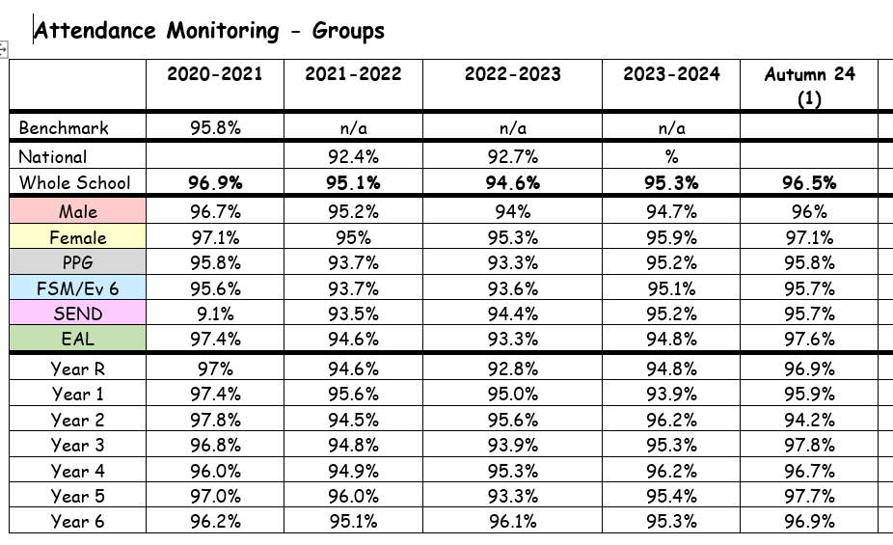

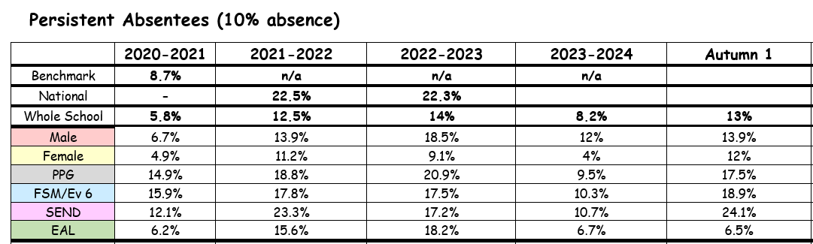

Attendance overall is in line with the national expected figure of 95%. The attendance figure for disadvantaged pupils remained below the whole school figure for the second year in a row although only by 0.2%.
Persistent absentees need further monitoring. The attendance officer ensures the strategy for improving the attendance of the disadvantaged pupils can be monitored more closely and support provide. The SENCO and Senior Mental Health Lead are working with some families to ensure children are receiving the emotional health and wellbeing support they need. Support from the Learning Mentor, Play Therapist, Mental Health in Schools Team or CAMHs is also in place for eligible pupils.

Externally provided programmes
Programme | Provider
NELI/Language Screen | Pearson/Oxford ed
TT Rock stars | Maths Circle
Number sense | Number Sense Maths Ltd
RWI Phonics | Oxford/Ruth Miskin Training
Vocabulary Ninja | Vocabulary Ninja
Accelerated Reader | Renaissance Learning

