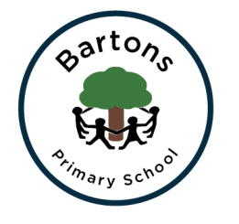
Year 1
Spring Newsletter 2022

Our topics for the Spring Term are ‘Taking Flight’ and then after half term ‘All Aboard!’ We begin the term by learning about the famous inventors and aviators, The Wright Brothers and Amelia Earhart. In Geography we will be learning how to use world maps, atlases and globes to identify the UK and its countries, as well as the countries, continents and oceans of the world. After the half term break we focus on other modes of transport such as trains and bikes. In History we will be learning about how transport has changed over the years and we will be visiting Amberley Museum. For more information you can find our learning journey on the class page on the school website.
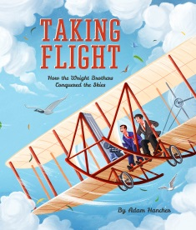
English
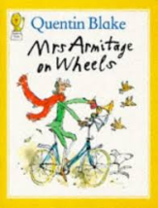
Our English work this term is focused on poetry, recount and diary (non-fiction) writing connected to the famous people we learn about in History. We start by reading, writing and reciting poetry. After half term we will be reading ‘Mrs Armitage on Wheels’ where we will be learning how to write a recount. Alongside our writing we will be continuing to work on our phonics in order to prepare for the Year 1 phonic test in the Summer Term.

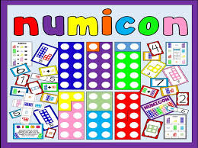
Maths
Our focus this term is to really know our number pairs to 10 and 20 and to group objects in 2’s, 5’s and 10’s to count quickly. We will be looking closely at 2D and 3D shape properties with Miss Windeatt every other Monday while also developing and deepening our knowledge of addition and subtraction.

PE
Our PE days are still Tuesdays and Thursdays. Please ensure that the children are wearing warm PE kit and remember to remove jewellery on these days. Please no shoelaces unless they can be tied by the children.

More information about the Phonics Screening Check:
https://www.gov.uk/government/publications/phonics-screening-check-sample-materials-and-training-video

Information for parents about the Phonics program we follow at Bartons:
https://home.oxfordowl.co.uk/reading/reading-schemes-oxford-levels/read-write-inc-phonics-guide/

Any problems or questions please send a message on Seesaw or ring the office and they will pass on any messages.

Mrs Hazelden, Mrs Spencer and Mrs Shaw.

