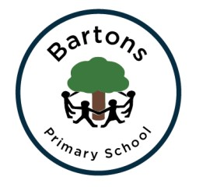
Year 4

Autumn Newsletter
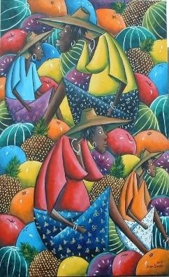
Topic
Welcome back everyone! We are so excited for the year ahead. Our topic for this half term is ‘Reduce, Reuse, Recycle and we will be focussing our English work on a fantastic book written by Tom Fletcher called ‘The Creakers’. In DT we will be learning new sewing skills as we create our own Creaker sock puppet out of old materials. Geography will be a vital part of this half terms learning, focussing on land use and settlements. We will of course be continuing our learning of French, PE, RE, Science and Computing. We are incredibly lucky to have an external music teacher coming in to teach us music every Wednesday.
After half term we will look at a brand-new topic ‘Out of Africa’ a topic we are extremely excited about. With a focus on the artist Dion Lewis we will create our own African styled artwork. For more information, you can find our learning journey on the class page on the school website. You can also see the learning for the rest of the year on the Year 4 curriculum page.

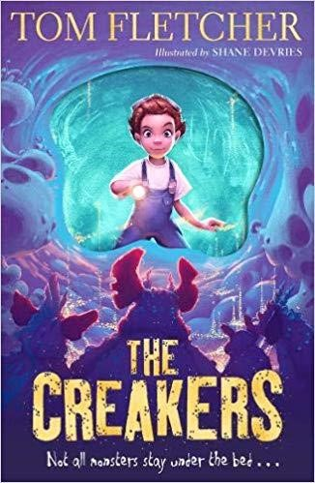
English
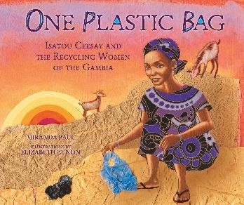
Our English work this half term is focused on writing a story based around fear and suspense. We have started reading ‘The Creakers’ and the children are captivated. We will be focussing on the skills needed to create a piece of writing that can build fear and suspense for the reader. After half term our book will change to ‘One Plastic Bag’ and our focus will be to write a story focussing on a ‘rags to riches’ theme. We will be writing a story where a character turns something of little to no value into something priceless. Alongside our writing we will be continuing to work on our spellings. Ash class will be given ‘Spell its’ which will be regularly practised and tested.
Handwriting and reading activities will take place daily to ensure progress is successful.
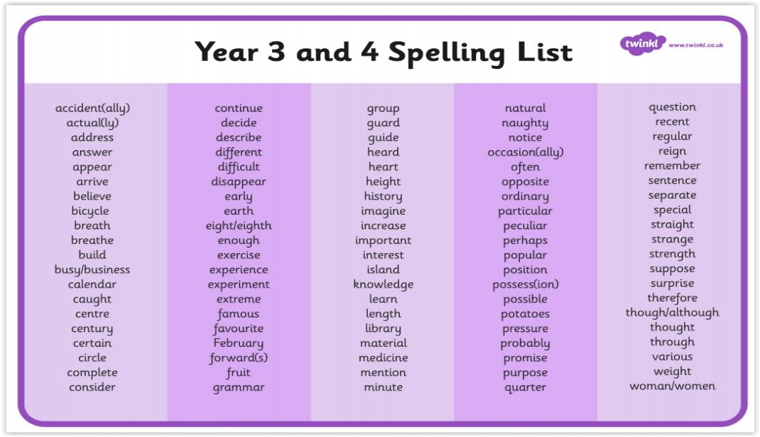

Maths
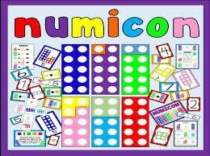
Following the Numicon approach, we hope the children will continue with their love of exploring with all the different equipment and will show us their confidence as they experiment with different methods. We will be introducing the inverse as our first topic; we will then revisit dividing.

Homework
Homework will be set every Friday on SeeSaw and will be due in the following Thursday. The children can earn house points for completing the activities set which may include Maths, English or topic work linked to our learning. Children can complete work in their homework books but these need to stay at home. Children can take a picture of their work and upload it to SeeSaw to get their feedback. It is also the expectation that children are reading for 15 minutes a day, practising their spellings and doing daily times tables practice (this can be done on TTRockstars).

PE
Our PE days are Tuesdays and Thursdays. Due to COVID-19 restrictions children will need to come to school in their PE kit and we will be outside where possible so please ensure that your child has suitable clothes and footwear and a named water bottle.

Important dates:
Friday 18th September – Maths Investigation day
Monday 26th – Friday 30th – October half term
Friday 13th November – Children in need -Non – uniform day £1 donation
Monday 16th November – Science day
Friday 11th December – Christmas jumper day
Thursday 17th December – Break up for Christmas
Friday 18th December – No school for children

Please check the school website and weekly Headteacher’s newsletter for the latest information.
If you have any concerns or questions please do not hesitate to email the office of speak to us.

Thank you for your continued support,

Mrs Calton and Miss Cook

