 | Autumn 1 | Autumn 2 | Spring 1 | Spring 2 | Summer 1 | Summer 2
Topic | Into the Woods | Heroes | Taking Flight | All aboard! | Street Detectives | Amazing Animals
English | The Gruffalo  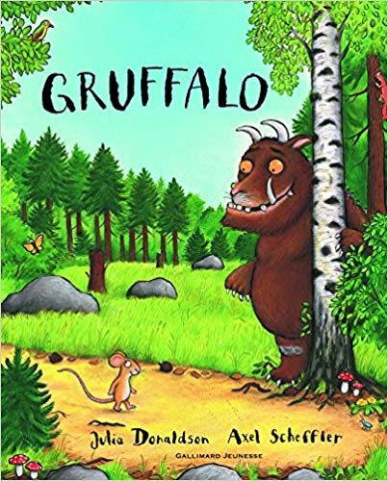 | Awesome Man   | Taking Flight  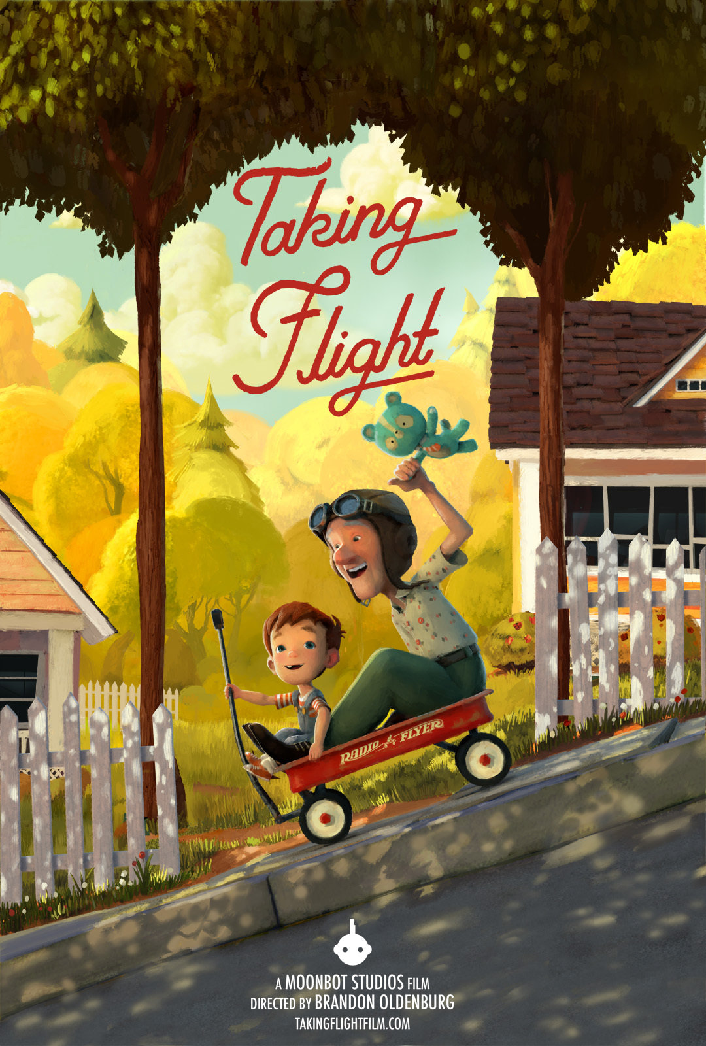  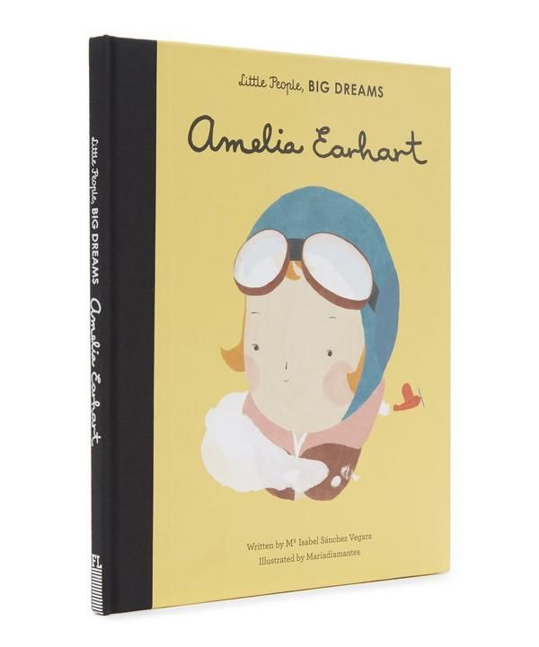 | Mrs Armitage on wheels  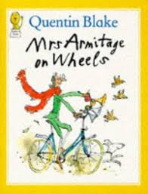 | Paddington’s Post  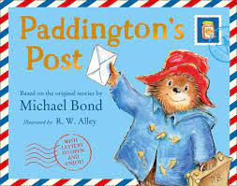  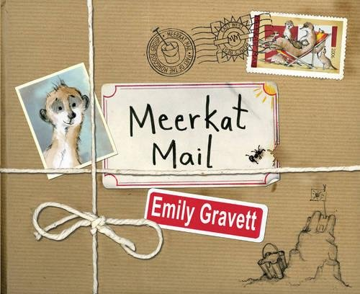 | Animal Texts  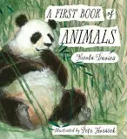  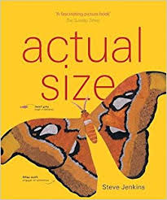
Science | Plants  Common Animals  Seasonal changes | Animals Including Humans (Humans)  Humans - Bodies & senses  Seasonal changes | Science Week  Flight investigation Materials | Everyday materials  (Bikes) | Plants investigation  (Jack and the Beanstalk) | Animals Including Humans (Animals)  (Marwell Zoo visit)
Computing | Using computers and laptops | Pic collage  2type for computer skills | E-Safety  Microsoft Word | E-Safety (Digiduck) | Bee-Bot  E-Safety (trusted adults)
History |  | Grace Darling & RNLI  Florence Nightingale  & Mary Seacole | Wright Brothers  Amelia Earhart | Transport time lines  (Amberley Museum visit) | Houses past and present
Geography | Mapping fictional places | Weather/seasons book | Continents and Oceans | UK countries and capitals | Compass points  Our school grounds and local area | Contrasting non-uk country: Borneo rainforest, Asia  Animals around the world
Art |  | Roy Lichtenstein – Whaam |  | Van Gogh | Lowry
Design Technology |  | Design and make Superspoons  Design and make a cape | Paper Airplanes/Kites investigation | Axel investigation | Design and make healthy snack (picnic) | Orang-utans – Moving parts
PE | Gym  Games | Dance, Gym | Ball skills, Tennis | OAA, Attack and defend skills | Games, Striking and fielding skills | Athletics, Striking and fielding skills
PSHCE | People who help us |  | Friendships
School Value | Independence | Respect | Communication | Happiness | Responsibility | Creativity
WWO
RE | Caring for Others | Gifts and Giving | Friendships | Easter and Surprises | Religion and Rituals | Places of Worship
Music | Ballet Music  The Nutcracker | Christmas Production | Monster Make | No place like | Space | Animal Crackers

