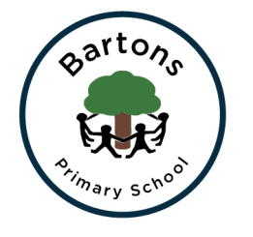
Year 2
Autumn Newsletter

Welcome back to another exciting year at Bartons; hopefully you all had a wonderful summer break. The children have settled in so well into Year 2 and I have been impressed with the positive attitude towards learning so far. We are very lucky to have Mrs Cook alongside myself, ready to support Chestnut Class as well as Miss Windeatt supporting us in English.

Topic
This half term our topic is ‘Field to Fork’ where we will be focusing on food and where it comes from. We may even get the chance to make some delicious fruit kebabs. The second part of the Autumn term our topic will be ‘Up in Smoke’ where we will be looking at the Great Fire of London and the Gunpowder Plot.

English
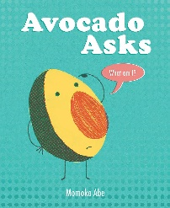
Our English writing focus this half term is story writing, focusing on ‘Avocado Asks’ by Momoko Abe. Alongside our writing we will be continuing to work on our grammar, spelling and phonics in order to prepare for the end of Year 2 SATS, more details to follow. We will also continue our hard work on handwriting which will be supported by daily activities. Daily reading will also be vital for the children to reach the expected standards at the end of the year. This will be supported by regular whole class reading sessions where we will be focusing on the different reading skills the children need to develop.
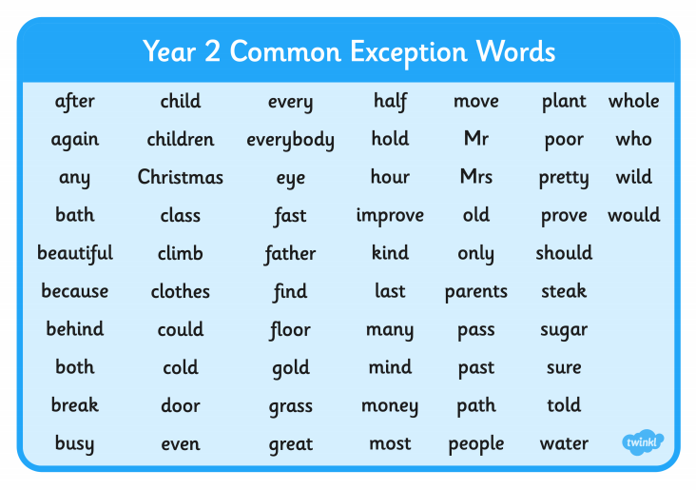

Maths
We are continuing to follow the Numicon approach which the children are now experts in! This half term we will be securing the skills we learned in Year 1 before developing them further when exploring the Year 2 objectives. These include further strategies for addition and subtraction, while introducing multiplication and division.

Homework
Take Away Tasks will continue to be set every Friday and will be due in Wednesday. The children will be expected to upload pictures / videos of their completed tasks onto SeeSaw. The children will receive spellings and a maths activity.

PE
PE will be every Tuesday and Thursday. Please ensure your child comes into school wearing their full PE kit on these days. If your child has their ears pierced we ask that the earrings are removed before coming to school on these days.

How can you help?
- Regular reading at home where you can share stories, asking and answering questions about what you have read.
- Ensure they have their school reading book in school every day as the children will be expected to read it after lunch, a time where those who are on Accelerated Reader can complete their quizzes.
- Encourage them to complete their homework tasks while letting them develop their independence.
- Check our class page on the website to discuss their learning further.
- The children need to be at school promptly in the morning at 8:50am.

Any problems or questions please do not hesitate to come and see us.
Miss Grimsey and Mrs Cook
Year 2 Team

