Ash Class Newsletter
Summer 2024
Dear Parents and Carers,
Welcome to the Summer term and hopefully some warmer weather.
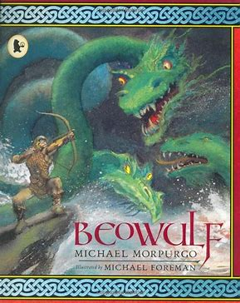
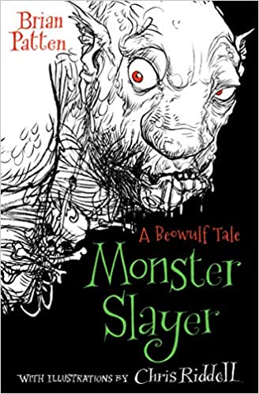
This terms topic is ‘Myths and Legends’. We will be focusing on the period of History called the Anglo-Saxons and reading the famous Saxon legend ‘Beowulf’. There are many versions of this legend, and we will be reading several versions to compare them.

Reading in class will focus on understanding the text and being able to answer questions based on the text. Reading is a daily homework. Remember you can hear your child read, you can read to them and you can discuss books together. What is important is that it happens regularly.
Our writing focus is to write a story with a clear beginning, middle and end. The children will be developing their vocabulary so they can write an interesting description of different settings and characters. Accurate spelling is also a focus.
In maths we will be practicing all the written methods to ensure fluency. We will also learning more about fractions and decimals.
Children are recalling their times table facts more quickly and accuracy is improving. Please encourage your children to keep practising particularly the individual table facts they do not know.

In Design and Technology, we will be exploring how pop-up books are made and then making our own pop up books using a range of pop up mechanisms.

PE. From the week beginning 22/04/24, PE days will be Wednesday and Friday. As the weather gets warmer, the children must wear dark plain shorts with their house T-shirt. All children need a water bottle.

Djembe Drumming. We have been lucky to secure more drumming lessons this term. The children have made really good progress with singing, holding a beat and repeating rhythms. We look forward to seeing what they achieve this term.

Homework Please check Seesaw regularly for homework. This will always be set on a Friday and due in the following Thursday. Homework is important and should be completed.

If you have a question or you have a concern about your child, please do not hesitate to see me.

Kind regards

Mrs Lewis

