Ash Class Newsletter
Summer 2023
Dear Parents and Carers,
Welcome to the Summer term and hopefully some warmer weather.
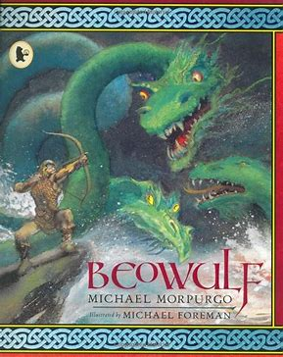
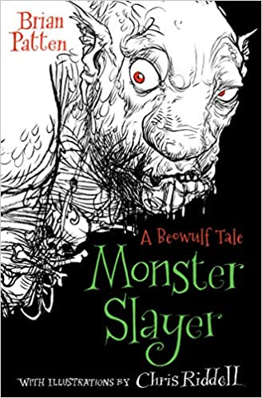
This terms topic is ‘Myths and Legends’. We will be focusing on the period of History called the Anglo-Saxons and reading the famous Saxon legend ‘Beowulf’. There are many versions of this legend, and we will be reading several versions to compare them.

Our writing focus is to write a story with a clear beginning, middle and end. The children will be developing their vocabulary so they can write an interesting description of different settings and characters. Accurate spelling is also a focus.
In maths we will be practicing all the written methods to ensure fluency. We will also learning more about fractions and decimals.
Children are recalling their times table facts more quickly and accuracy is improving. Please encourage your children to keep practising particularly the individual table facts they do not know.

In Design and Technology, we will be exploring how pop-up books are made and then making our own pop up books using a range of pop up mechanisms.

PE. PE days will continue to be Wednesday and Thursday. As the weather gets warmer, the children must wear dark plain shorts with their house T-shirt.

Homework will continue to feature daily reading and times table practice. Please check Seesaw regularly.

If you have a question or you have a concern about your child, please do not hesitate to see me.

Kind regards

Mrs Lewis

