Ash Class Newsletter
Spring 2023
Dear Parents and Carers,
Happy New Year. We hope you have had a restful holiday and are looking forward to an exciting Spring term.
We start the term off with a new topic ‘ Seeking Refugee’. We will be researching the journeys refugees make to safety and the push and pull factors that cause refugees to leave their homes. This links to our class book ‘A story like the wind’ by Gill Lewis.
Our writing will focus on writing to inform-an information leaflet and poetry about ‘moving on’. There will be a particular focus on using a wider range of appropriate vocabulary and using the correct grammar in sentences.
In Maths we will learning about negative numbers and addition/subtraction column method. The children’s recall of all table facts has improved hugely since September, and we will be continuing to focus on this.
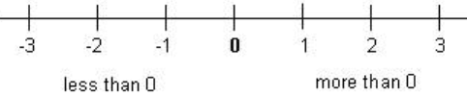
PE
The children need to come to school in PE kit on Wednesday and Thursday. Please make sure they have warm dark joggers and sweatshirts as we will be outside if the weather is dry. Thank you for ensuring earrings are removed on PE days.

Design and technology
We are going to be learning skills used in cooking such as cutting and kneading. Every week we will follow a recipe and make a food item. These lessons will be on a Friday. Please can you send you child in with an apron on a Friday.
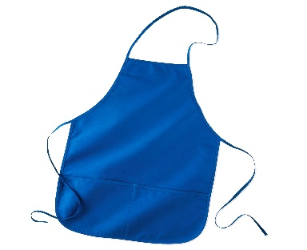

Homework
Regular practice of Times Tables facts and reading at home is essential for your child to make progress in these areas. Children who have practiced regularly at home, have made the most progress in the Autumn term. Please support you child to complete homework. We will be continuing to use Seesaw and the online platforms Mymaths and TTRockstars. Any problems, please see Mrs Lewis. Homework will be set on Friday and completed by the following Thursday.

Thank you for your on-going support. Any questions or concerns, please contact me.

Kind Regards
Mrs Lewis

