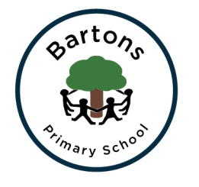
Year 1 Autumn Newsletter
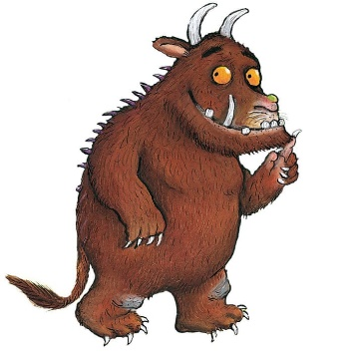
Welcome back to Bartons! The children have settled in well and are adjusting to life in Year 1. We have planned the learning to support their love of play while beginning the Year 1 curriculum.
Topics
Our very first topic is called ‘Into the Woods’ where we will be learning to write stories inspired by traditional tales and ‘The Gruffalo’ by Julia Donaldson. We will focus on identifying common plants and animals in science and learn to follow and make maps in Geography. In computing we will be learning how to use the computers safely.
After half term our Topic is ‘Heroes’ and we will start by focusing on Super heroes and then move on to real life heroes. We will be creating Pop Art inspired by Roy Lichtenstein and making our own superhero super spoons and capes! For more information you can find our learning journey on the class page on the school website. After half term: Please could your child bring in an old adult sized T shirt, we will be creating our own superhero capes in Design and Technology!
English
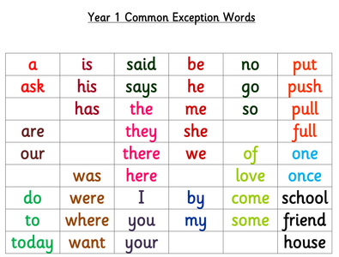
Our English work this half term is focused on correct sentence formation and our ‘Every time we write’ skills. Alongside our writing we will be continuing to work on our phonics in order to prepare for the Year 1 phonic test in the Summer Term, more details will follow. We are learning to spell the Year 1 common exception words (words that are not easily decodable using phonics) over the year. Please support your child with learning to read and write these at home:

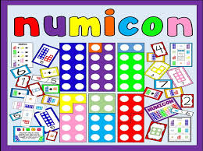
Maths
We are continuing to follow the Numicon approach which the children started when working in Reception. The children will be recognising the Numicon Shapes, sorting and ordering them. We will also be making repeating patterns and sequencing events before telling number ‘stories’ ready for calculating.
PE
PE kits (including trainers or plimsolls) will be worn to school on Mondays and Thursdays. School jumpers/cardigans should also be worn. If your child has earrings they must be removed on these days. As the weather gets cooler please send them in wearing tracksuit trousers for when we go outdoors.
Show and Tell
Show and Tell will be on the first Friday of each month. We encourage the children to try to connect their show and tell with what we have been learning, our topic, particular recent achievements or special events outside school. For example extra maths work they have done at home or a favourite story they have heard or written. This is not compulsory and they do not have to contribute every month!

How can you help?
- Regular reading at home (not just their school book), sharing stories and asking and answering questions about what they have read.
- Regular counting forwards and backwards, identifying coins and telling the time.
- Supporting homework tasks while letting them develop their independence.
- Regular short sessions testing their common exception word spellings.
- Lots of drawing, colouring in, doodling and writing.

Any problems or questions please email the school office office@bartonsprimary.school who can forward them on to me.

Mrs Hazelden, Mrs Shaw and Mrs Spencer

