Ash Class Newsletter
Autumn 1 2022

Dear Parents and Carers,

Welcome back after the summer holidays. We have enjoyed getting to know the children in Ash class and look forward to all the exciting learning to come.
We have a great topic to start with ‘ Somewhere to Settle’. This will include using maps, exploring different types of settlements and how artwork enhances the environment we live in. This will include visiting The Bersted Park Art Trail. In science we will be learning about electricity safety and investigating electrical circuits.
English 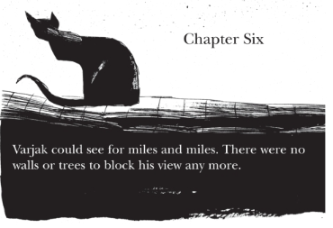
We will be reading a range of ‘fear and suspense’ tales including the book Varjak Paw. This will lead to the children writing their own setting description for a suspense story. The focus will continue to be on saying and writing good quality sentences. This will include accurate punctuation and spelling.
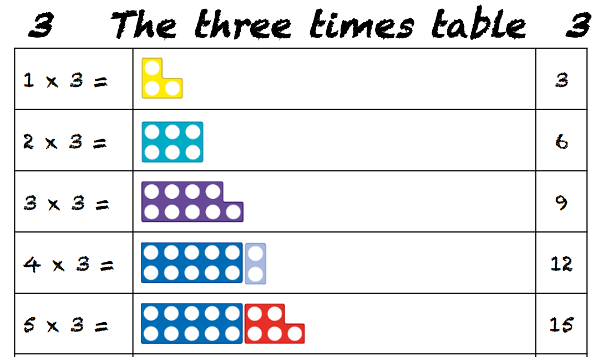
Maths
We will continue to develop our Maths skills through the Numicon approach. There is a focus on ensuring the children become increasingly fluent with larger whole numbers and the four operations. Times tables are a big focus as at the end of Year 4 there is a Multiplication Tables check (Gov.uk). I will be holding a meeting for parents shortly to explain this newly introduced check.
PE
Our PE sessions are Thursday and Friday. The children need to wear school PE kits on these days. Please ensure earrings are removed. As the weather gets colder, your child might need plain, dark coloured joggers and a sweatshirt.

Homework
Please support your child’s learning through encouraging regular reading and times table practice. 15min daily practice is more effective than 1 longer session a week. The school provides online platforms Mymaths and TTrockstars to support learning at home.
We will be using Seesaw for a variety of homework. Your child will need access to a computer/tablet. If this is a problem, please see Mrs Lewis.
Any questions or concerns please get in touch. If you would like an appointment, please contact the office for a mutually convenient time.
Kind Regards Mrs Lewis and Mrs Byng

