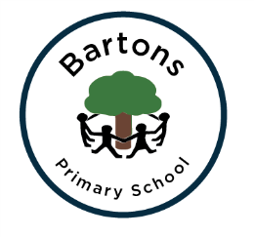 | WEST SUSSEX COUNTY COUNCIL  BARTONS PRIMARY SCHOOL Headteacher: Mrs Kate Powell  Lethaby Road, Bognor Regis,  West Sussex PO21 5EJ  Tel no. (01243) 822056 Fax no. (01243) 841580  email: office@bartonsprimary.school

14th June 2018
Dear Parent/Carer

As part of the school’s Personal, Social and Health Education programme, your child will soon receive a unit of lessons on relationships, sexual health and personal safety.

The purpose of the upcoming unit is to provide knowledge and understanding of safe and healthy relationships based on love and respect. This is to encourage the eventual development of safe and healthy relationships in later life. The unit will develop understanding and attitudes which will help pupils to form relationships in a responsible and healthy manner and to appreciate the value of stable family life, including the responsibilities of parenthood and marriage. The unit will also cover the physical development of their bodies as they grow into adults.
You are invited to attend a meeting on Friday 22nd June at 3:30pm in Cedar class to view the video clips that will be shared with the children during the programme.
Parents have the right to withdraw their children from all or part of sex and relationships education that does not form part of the statutory National Curriculum. If you wish to withdraw your child from the lessons on sexual health and safe relationships would you please return the-opt out slip below before the programme starts. The programme will begin during the week beginning 2nd July 2018.
You are welcome to contact me to discuss the programme further, should you wish to.
Yours sincerely,

Mr Hayne
……………………………………………………………………………………………………………………………………………………….
I would like to opt my child out of the sexual health and safe relationships lessons.

…………………………………..……………… ………………………………………………………
Name of child Signature of parent

