Half Termly Home Learning Menu – Ash Class
Autumn 1: Somewhere to Settle | Spring 1: Seeking Refuge | Summer 1: Myths and Legends
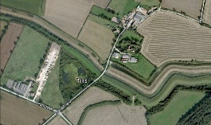  Design your own perfect settlement. Draw a map of your settlement and label all the essential features that make it perfect.  Write instructions for how to get from home to school.  Draw a picture of the view from a window in your house.  Create a leaflet persuading people to visit West Sussex. | Make a room in a shoebox that represents the importance of home for you.  Learn a few words in a different language. Welcome’ is a great one!  Write a letter to a refugee who has recently arrived in the UK. What would you like to tell them to make them feel welcome? | 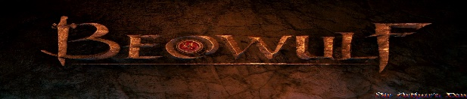  Make a Myth or legend into a comic strip.  Design your own mythical creature. Make a model of it using recycled materials.  Design your own maze using drawings, blocks (like lego) or computing.
Autumn 2: Out of Africa | Spring 2: Off with her head! | Summer 2: Go with the flow
Write a story about going on a safari in Africa.  Research an African animal and use the facts to create a poster.  Research African fabric. Design a pattern for an African fabric.  Create geographical accurate map of Africa.  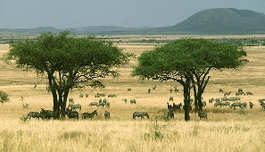 | Design a quiz about the Tudors.  Research Tudor food. Compare food eaten by the poor to food eaten by the rich. Choose how to present the information.  Design a flag or shield to represent you and your family.  Research Tudor-style purses and re-create one. | Go under water to find out what lives in a river. Choose how present the information.  Research a famous river (UK /world)  Choose how to present the information.  Make a model of a river from source to sea. Label the different parts.  