 | Autumn 1 | Autumn 2 | Spring 1 | Spring 2 |  | Summer 1 | Summer 2
Topic | ‘Somewhere to Settle’  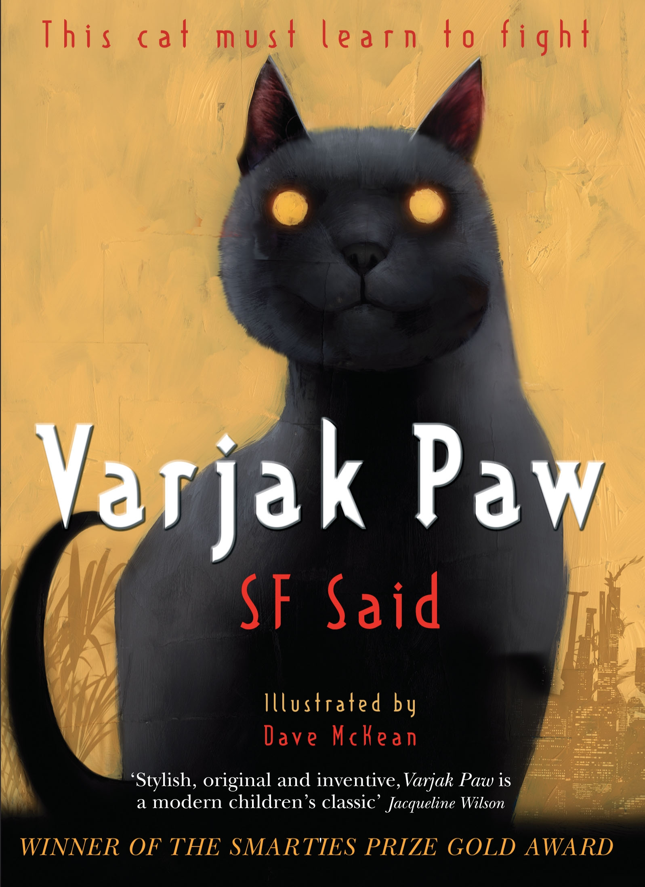 | Out of Africa  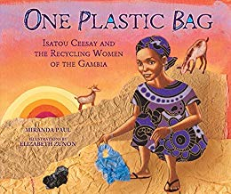  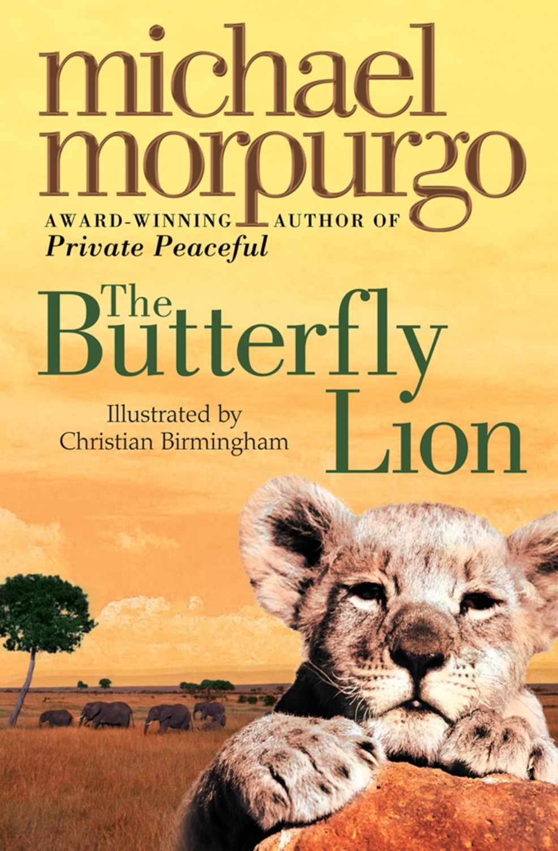 | ‘Seeking Refuge’  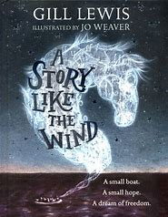 | ‘Off with her head!’  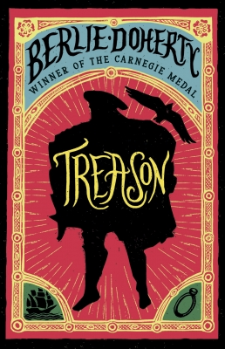 |  | Myths and Legends  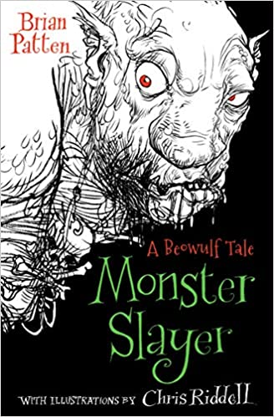 | Go with the flow  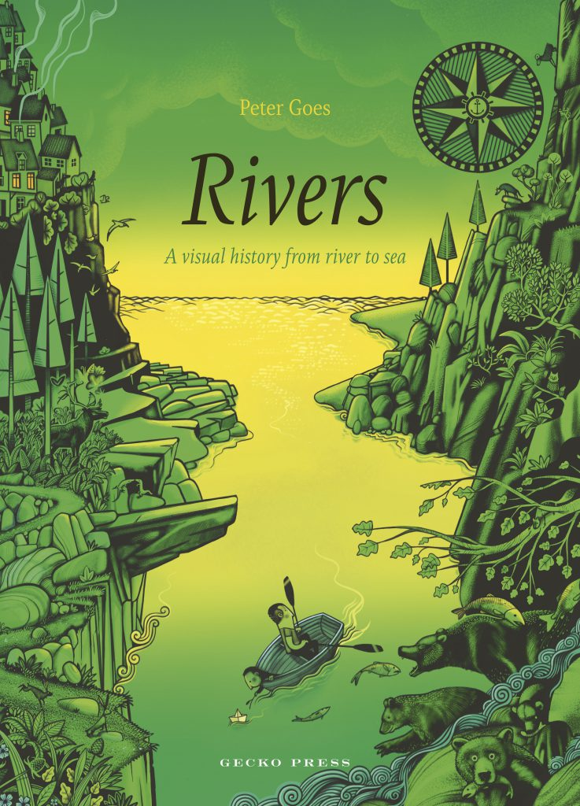
English | Setting for a Fear and Suspense story.  Poetry. Night description  Book - Varjax Paw | Explanation writing.  Narrative writing.  Book - One plastic Bag  Book – Butterfly Lion | Character description  Information writing  Book – A story like the wind. | Recount writing  BOOK- Treason  Shakespeare. |  | Conquer the monster story writing.  Book -Beowulf | Writing linked to the water cycle in a narrative style.  BOOK= Rivers
Science | Electricity | States of matter | Science week  Digestive system  Teeth | Sound |  |  | Food chains  Living things and their habitats
Computing | Scratch – creating algorithms  Online safety – social media | Scratch – creating algorithms  Digital images | Search Engines | Video uploads  green screen |  | Scratch – creating  Algorithms  Networks | Video uploads  green screen
History/ Geography | Human Geography, land use and settlements.  UK map. | Africa – climate zones/human geography  Locating world countries |  |  | Monarchs, Tudors, Tudor Life, Henry VIII, Shakespeare | Saxons  Germany linked to Saxons | Rivers  compass points, symbols on OS map
Art/ Design Technology | Creating sculpture with reused materials - e.g. cardboard.  Different ways of joining carboard. | Block printing  African art.  Oil pastel and acrylic paint – Poppies | Food tech – heathy balanced meal.  Dynamic Sketching with Peter Hann. | Tudor Portraits  Jinx frame – Tudor house |  | Make a pop-up book about a myth / legend  Create/ paint mythical creature | Bridges – Monet painting inspiration  Bridge making
PE | Hockey  Gymnastics | Striking and fielding  Outdoor and Adventurous activity | Dance  Ball skills | Striking and fielding  Dance |  | Athletics  Tennis | Cricket  Rounder’s
PSHCE | Feelings and emotions | Safety rules and laws | Physical activity and nutrition | Friendships and bullying. |  | Drugs education | Body changes
Core Values | Independence | Respect | Communication | Happiness |  | Responsibility | Creativity
RE | Judaism  Beliefs and Practices | Christianity  Christmas | Buddhism  Buddha’s teachings | Christianity  Easter |  | Judaism  Rites of Passage and good works | Christianity  Prayer and Worship
French | Presenting myself | Family | Transport | Shapes |  | Nursery Rhymes | Seasons and weather
Music | Mamma Mia  Listen and appraise  Playing musical instruments.  Perform and share. | Christmas  Listen and appraise  Playing musical instruments.  Perform and share. | Stop!  Listen and appraise  Playing musical instruments.  Perform and share. | Learn on me!  Listen and appraise  Playing musical instruments.  Perform and share. |  | Blackbird  Listen and appraise  Playing musical instruments.  Perform and share. | Summer production  Listen and appraise  Playing musical instruments.  Perform and share.

